|  |  |  |  |  |  |
| --- | --- | --- | --- | --- | --- |
| Date | 1-Dec-22 | | | Tester Name | Shahabuddin Syed |
| Environment | Penfax - Test | | | Login used |  |
| Operating System | Windows | Version: | Update: | | |
| Software Used | Edge | Version: | Update: | | |
| Select Software | Version: | Update: | | |
| Release version | 22.4.1 | | | | |
| Title | E21.01c | | | | |
| Test Type | Regression | | | | |
| Test Scenario | Case Management – Create a Employer Contribution Case & update the task due date & reminder date | | | | |
|  |  | | | | |
| Expected Results |  | | | | |
| Pass/Fail | Pass | | | JIRA# | N/A |

Describe your steps with screenshots:

Case Management – Dashboard

Click on Add case

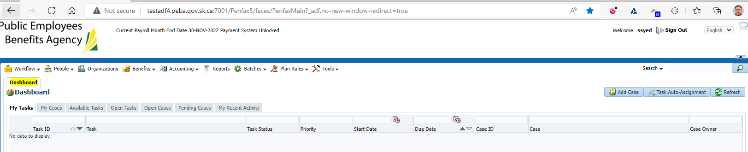

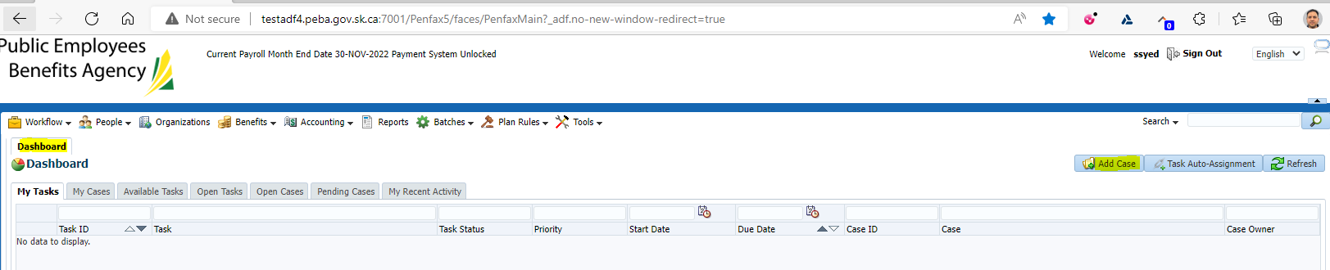

Select PEPP Employer Contribution Processing

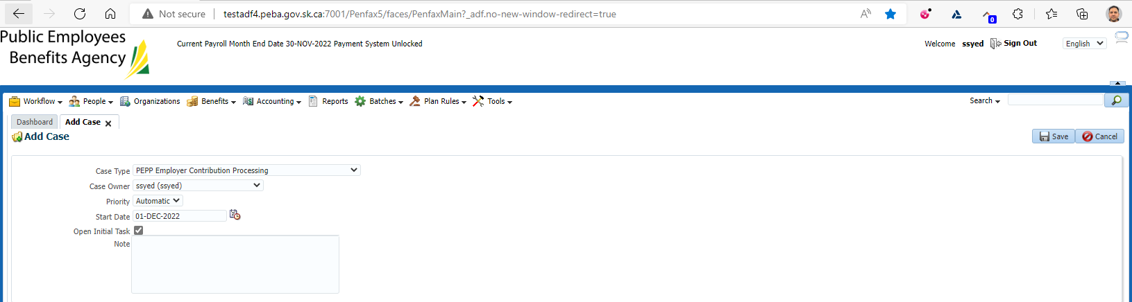

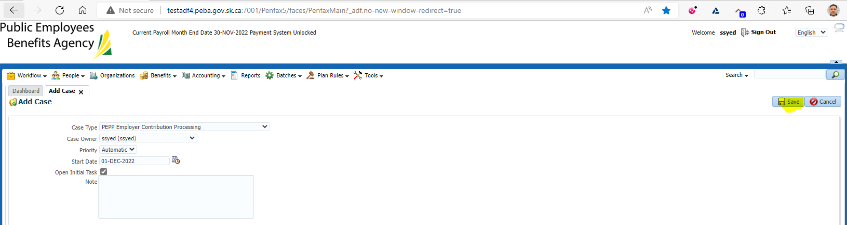

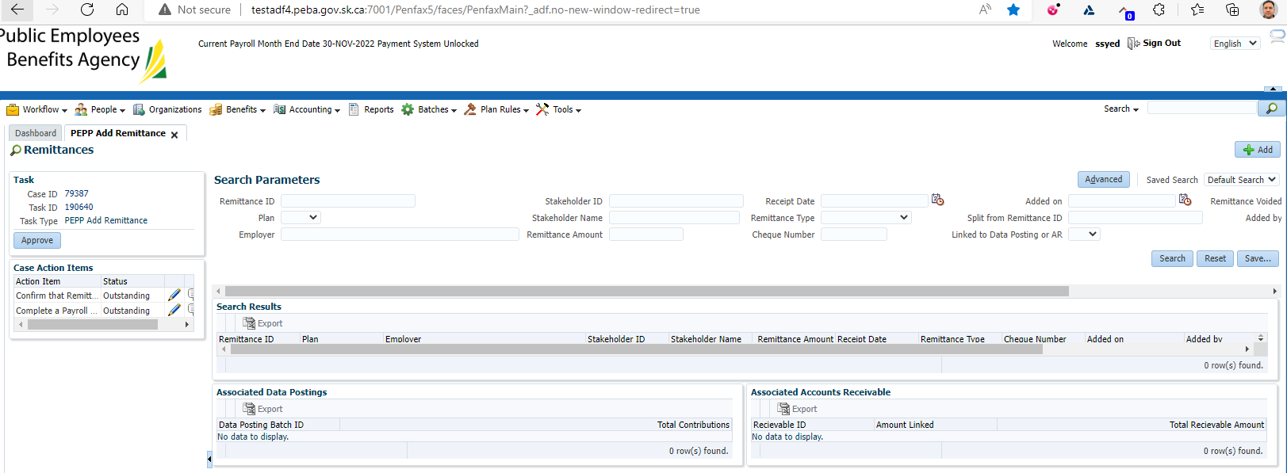

Click on Task ID Number: 190640

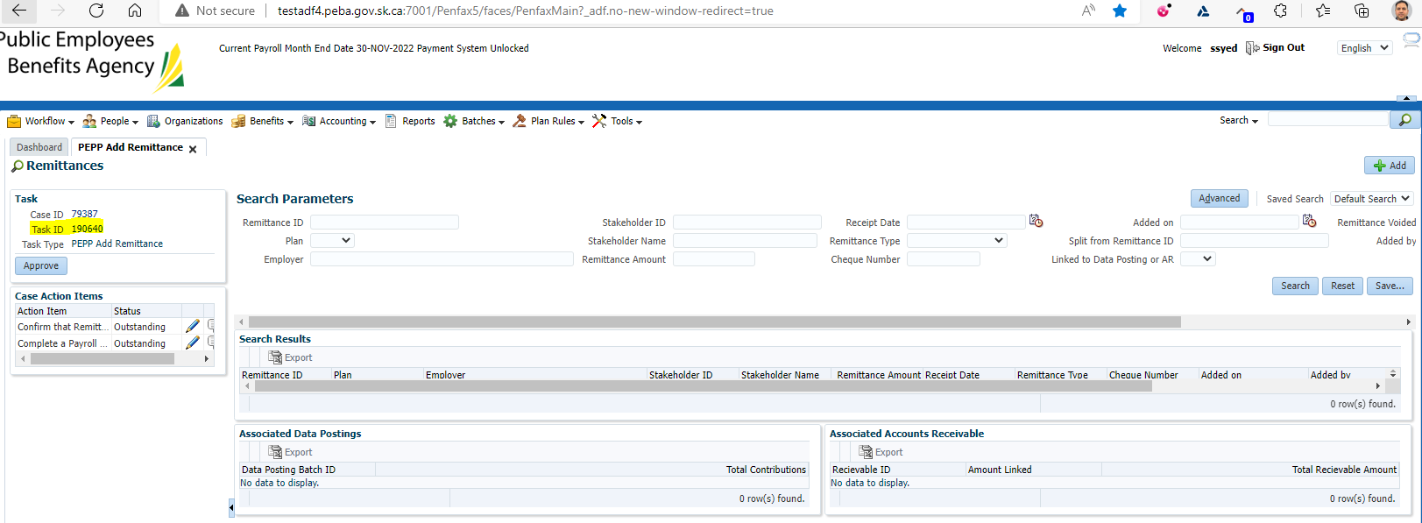

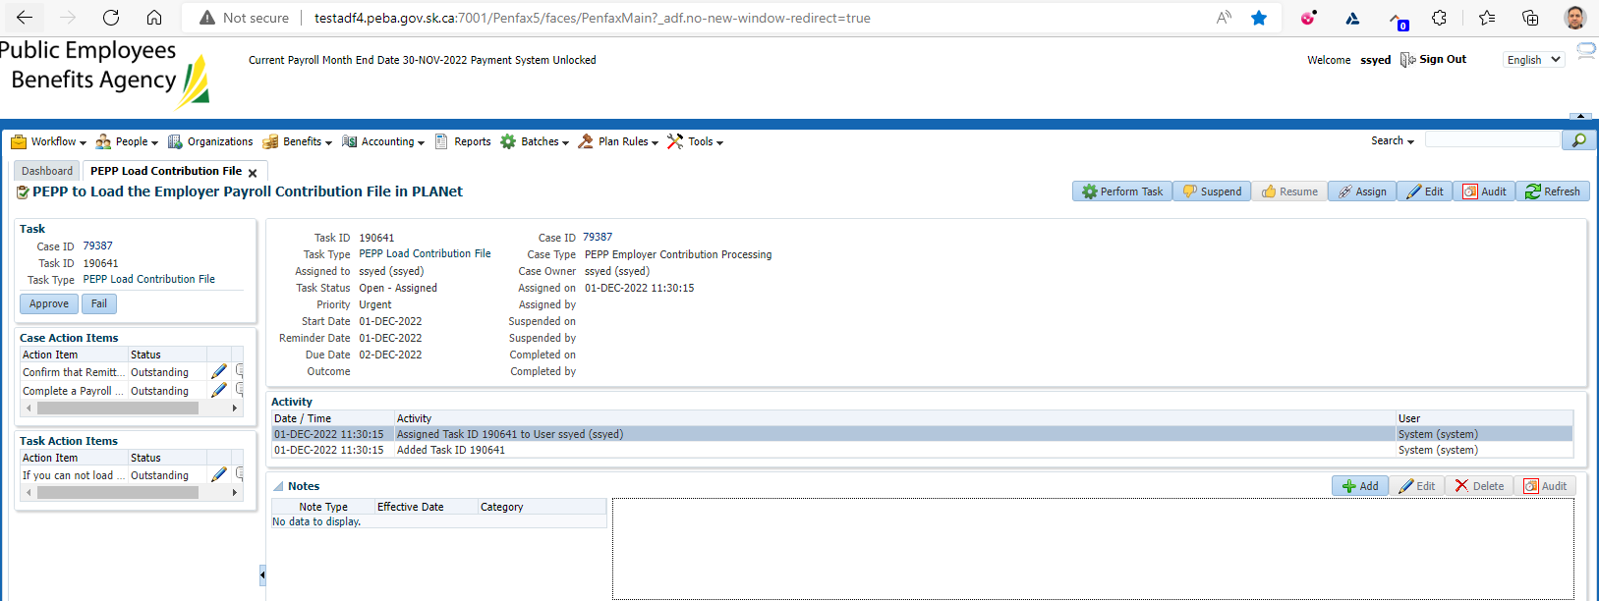

Update the Due date & reminder date

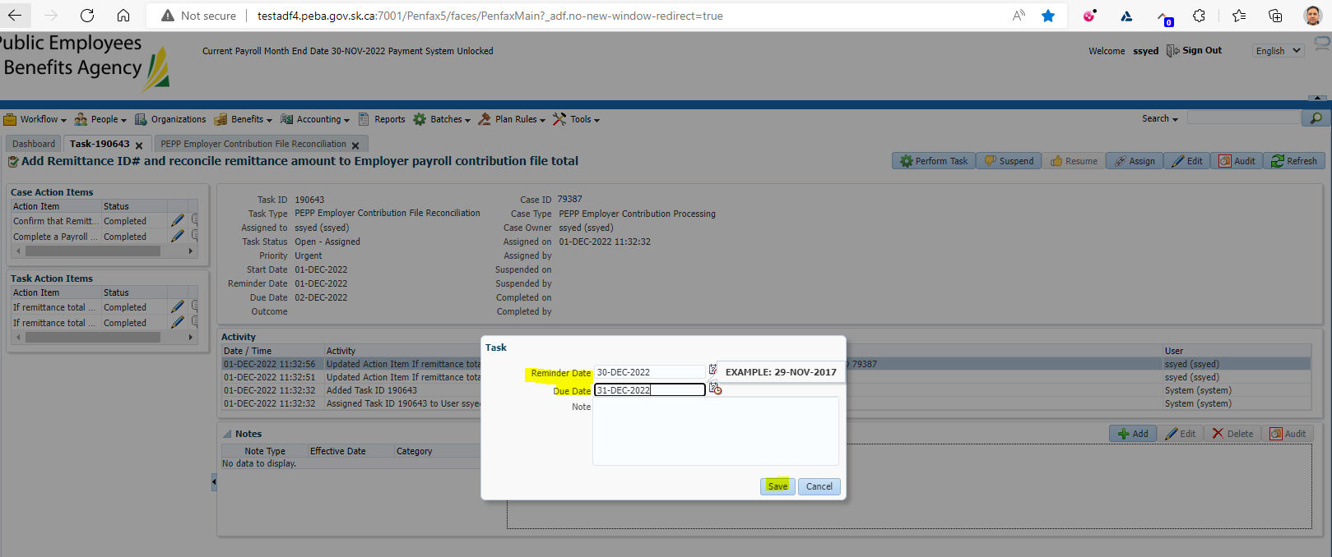

Need to update the task

Need to change the Status from Outstanding to Completed

